### Palette

The palette is meant to give a quick selection to change the color settings of the screen. When you click the button, you’ll be presented with 4 choices (see Figure 1‑3).

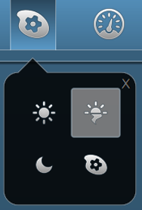

Figure 1‑3: Palette options

From left to right (beginning top left), there are three predefined buttons: Day, Dusk and Night. These choices give you the right colors and brightness for these specific periods of time. The last one is the palette selection tool. Using this, you can change the colors of the three presets to your liking.

* When you change the colors of a preset, be aware that there is no “Default” setting. It might be hard to get the colors back to their old state.*